Q1. WAP C++ program to illustrate the concept of class and object with example

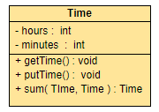

Q2. WAP C++ program to illustrate the concept of friend function with example

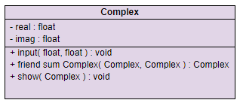

Q3. WAP C++ program to illustrate the concept of constructor & destructor with example

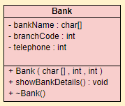

Q4. WAP C++ program to create the shallow/deep copy of customer with example

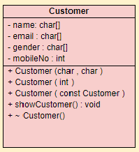

Q5. WAP C++ program to illustrate the concept of operator overloading with example

